**Caremark.com - Sign In, Dashboard, and Sign Out**

Sign In without a Password Feature

Sign In with Username and Password

Multi Factor Authentication (MFA)

Caremark.com Dashboard

 Forgot Your Password

Forgot Your Username

Session About To Expire Pop-up Message

Log Out

Sign In Error Messages

Related Documents

**Description**: Instructions for members to Sign In with Username and Password, Sign In without a Password, View the Dashboard, and Sign Out.

Screen capture might not match the actual scenario for this process. Some clients may not enlist in specific web features. This work instruction/job aid is intended as a guide only.

|  |
| --- |
| **Sign In without a Password Feature** |

**Enrollment steps (Steps to set up feature for desktop and mobile web):**

1. Click the **Sign in without a password** link on CVS Caremark.com sign in page.
2. Click the **Sign in and enroll** link on the “**Let’s get you enrolled…**” page.
3. Sign in with the credentials (username and password) for which the user wants to create a passkey.
4. Complete identity verification

**Example**: Multi-factor authentication and one-time (1-time) passcode entry.

1. Click the **Continue** button on “Enroll in passwordless sign-in” page.
2. Follow the browser/device specific prompts to create a passkey.

7. Click **Continue to dashboard** on “You successfully set up passwordless sign-in” page.

**Sign in without a password. Member enrolled (feature already enabled):**

1. Click the **Sign in without a password** link on CVS Caremark.com sign in page.
2. Click the **Continue with sign-in** button on “**Sign in without a password**” page.
3. Follow the browser/device specific prompts.
4. Arrive on authenticated dashboard.

Top of the Document

|  |
| --- |
| **Sign In with Username and Password** |

Ask the member to perform these steps to Sign in:

Also refer to [Caremark.com Log in and Registration (Carrier to Carrier) Enhancements (058095)](https://thesource.cvshealth.com/nuxeo/thesource/#!/view?docid=dd7f8b9f-cf1b-4f7c-86f7-ac6e0a015452).

Members who have or have had more than one (1) plan with CVS Caremark in the past 36 months based on termination date have a new feature displayed on the dashboard titled, “**View my plans.”** This allows members to access any of their plans by just clicking on the link, selecting the plan they want to access, and sign in with the same username and password.

For users who only have one (1) username, there will be no impact.

* Type your **username** and **password**
* Click the **Sign In** button.

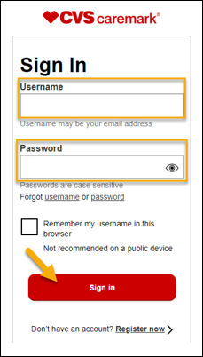

**Reminders:**

* **Username:** Is typically the member’s email address or might be a unique username the member created. Usernames are not case sensitive, can be 6 or more characters, contain one (1) number and one (1) letter, and cannot contain special characters or spaces. Access the **Profile** page on Caremark.com (regardless of registration status shown from Compass) to confirm registration and verify member is using the correct username.
* **Password:** Case sensitive, must be 10 to 32 characters long, include an uppercaseletter, lowercase letter, number, one (1) special character like / @ $ % &, and no spaces. If the member does not remember their password, ask the member to complete the Forgot Password steps to reset their password.
* Confirm the member is trying to sign in on Caremark.com (not CVS.com, CVSHealth App, or CVSSpecialty.com.
* Check the client CIF to confirm client is not SSO only.
* **Result:** The Caremark.com **Dashboard** displays.

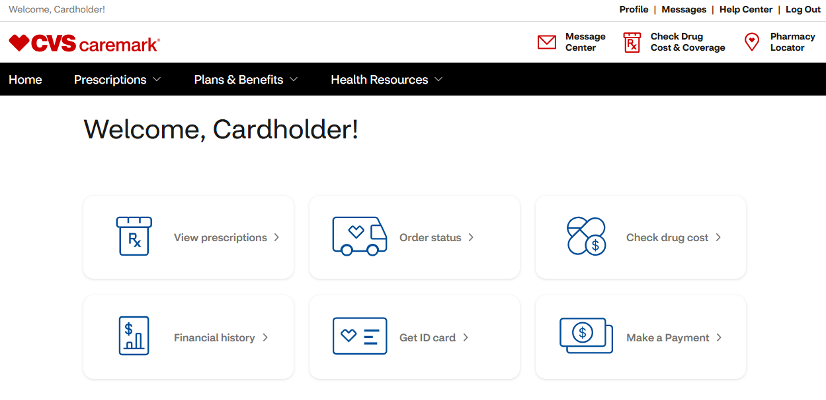

**Note:** If an incorrect username and/or password is inputted, the error message, **“Your login attempt failed. You entered an incorrect username and/or password”** will display.

* If **CAPS LOCK** is on, the member will receive a hint to indicate this.

Top of the Document

|  |
| --- |
| **Multi Factor Authentication (MFA)** |

Multifactor Authentication (MFA) has been implemented to improve authentication assurance for all Caremark.com users: Desktop, Mobile Web, and Mobile App. Refer to Caremark.com and Mobile Web – New Log In/Multifactor Authentication (MFA).

Members using biometric fingerprint and face recognition **are not** be presented with MFA.

Top of the Document

|  |
| --- |
| **Caremark.com Dashboard** |

After signing in, members are taken to the Caremark.com Dashboard.

Also refer to [Caremark.com Log in and Registration (Carrier to Carrier) Enhancements (058095)](https://thesource.cvshealth.com/nuxeo/thesource/#!/view?docid=dd7f8b9f-cf1b-4f7c-86f7-ac6e0a015452).

Members who have or have had more than one (1) plan with CVS Caremark in the past 36 months based on termination date have a new feature displayed on the dashboard titled, “**View my plans.”** This allows members to access any of their plans by just clicking on the link, selecting the plan they want to access, and sign in with the same username and password.

**Homepage/Dashboard Redesign:**

* Provides for a simplified Caremark dashboard.
* Dashboard displays access points to commonly visited pages to reduce lengthy page load times.
* Supports existing client personalization and branding.
* Features and content available on the Dashboard can vary and be client specific:
  + Informational content management spots
  + Links to finish setting up account. Member can also access their settings from the Profile page.
  + Links for Member Resources located at the bottom of the page

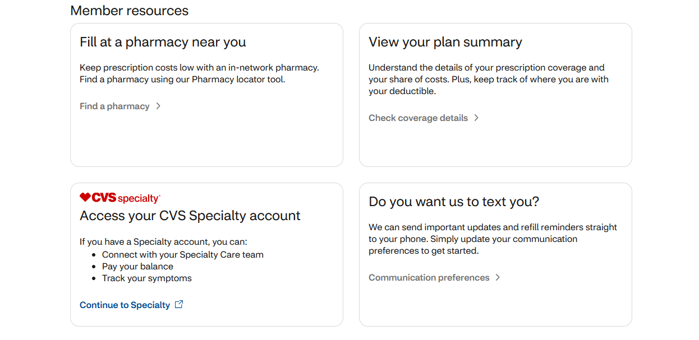

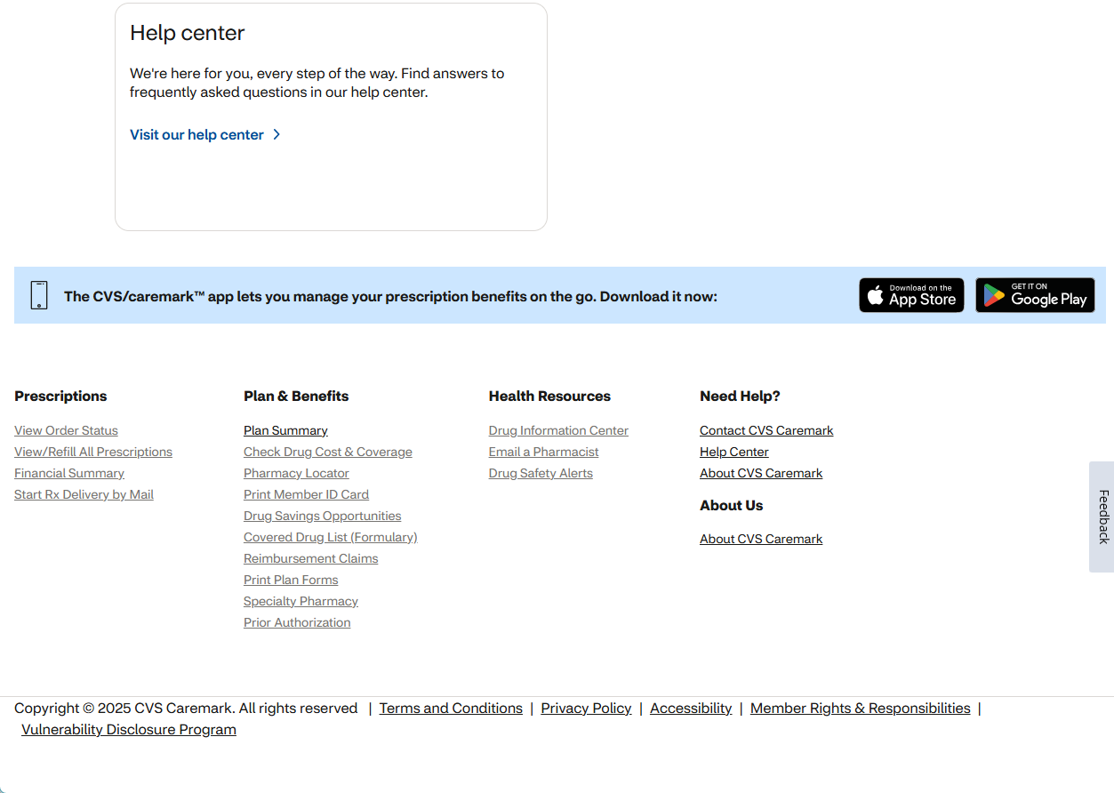

Top of the Document

|  |
| --- |
| **Forgot Your Password** |

Ask the member to perform these steps if they have forgotten their password:

|  |  |
| --- | --- |
| **Step** | **Action** |
| **1** | Access [www.caremark.com](http://www.caremark.com).  **Result:** CVS Caremark homepage displays.  Click **Sign In.** |
| **2** | Click **Forgot your password?** |
| **3** | **Forgot Password** page will populate. Member will enter their username and date of birth. |
| **4** | **Choose a way to receive a passcode** screen will populate. After member has selected how to receive the one time passcode they will click **Send passcode.** |
| **5** | **Enter the passcode we sent to…** page will populate. The member must enter the code they were sent by text or email. After the code is entered the member will click **Confirm passcode.**    **Note:** In some instances, there may be a delay with receiving the verification code before it expires within 30 minutes after it is requested depending on volume of alerts being sent.  Workaround for Customer Care to assist members and provide the member with the code:   * You **CANNOT** utilize this workaround **unless** the member has been fully authenticated with 4 authentication elements per the HIPAA Authentication Grid. If assisting another individual on the member’s behalf, you **MUST** speak to the member/beneficiary themselves (unless Power of Attorney (POA) OR Appointment of Representative (AOR) is in effect or member verbally authorizes at the time of the call to speak with someone else). Refer to the HIPAA Authentication Grid. * View the last email or text alert sent within the last 30 minutes by navigating to the Compass Quick Access panel, select Communications, then select Digital Communications and provide the member with the code to enter and login with. |
| **6** | **Reset you password and sign in** will populate.    **Note:**   * Remind the member that passwords are case sensitive. * Ask the member to confirm the CAPS Lock is not turned on and the number lock key is turned on. * Advise the member that no special characters can be used when creating a password. |
| **7** | **Success!** Will populate |
| **8** | The member will be directed to sign in with their **Username and Password.** |
| **9** | Member receives notification that their password has been successfully changed. |

Top of the Document

|  |
| --- |
| **Forgot Your Username** |

Ask the member to perform these steps if they have forgotten their username:

|  |  |
| --- | --- |
| **Step** | **Action** |
| **1** | Access [www.caremark.com](http://www.caremark.com).  **Result:** CVS Caremark homepage displays.  Click **Sign In**. |
| **2** | Click to select **Forgot your username.**    **Result:** The “We just need to confirm it’s you. Enter your information to help us locate your account” screen displays.  **Member types:**   * First name * Last name * Date of birth * Street address * Zip Code   Click **Continue**. |
| **3** | **Multifactor Verification.**  **Just need to confirm it’s you. Choose a way to receive a one-time** (1-time) **verification code.**  Choose a way to receive a one-time (1-time) verification code.   * Text (Option to send a text is available if member has enrolled in text messaging) **or** * Email   Click **Send the code.** |
| **4** | Type the code we sent to (mobile phone number or email will be displayed):  Click **Confirm passcode**.    **Result: Username** is displayed.   * Click to select **Back to sign-in** or * **Forgot your password** |

Top of the Document

|  |
| --- |
| **Session About To Expire Pop-up Message** |

For security reasons, members receive a warning after approximately 12 minutes of inactivity advising that their session will end in three (3) minutes at which time the member will be logged out automatically. Members are given the option to select **Continue Session** to remain signed in or **Sign Out** to end the session and log out.

Top of the Document

|  |
| --- |
| **Log Out** |

Click **Account**, then click **Sign Out** from the top of any Caremark.com page.

Top of the Document

|  |
| --- |
| **Sign In Error Messages** |

A variety of different error messages might display depending on the field that needs to be corrected. The error message displays on the same screen near the field where the error was made.

**Icon - Important Information** If the member inputs their username and/or password incorrectly three (3) times, the member will be locked out temporarily for 30 minutes.

**Examples** **below:**

|  |  |
| --- | --- |
| **Error Message** | **Illustration** |
| **Enter a valid password:**  **“We need you to check something**  **This password does not match our records. Check your password and try again.”** |  |
| **Enter a valid username:**  **“We need you to check something**  **This username does not match our records. Check your username and try again.”** |  |
| **Temporary 30-minute lock out** | **First incorrect Sign In attempt.**   * Two (2) more sign-in chances before account is locked.     **Second incorrect Sign In attempt.**   * One more sign-in chance left. * To prevent getting locked out, member can also create a new password.     **Third incorrect Sign In attempt.**   * Account has been temporarily locked. * Member can try to sign in again in 30 minutes. |
| **Access Denied/Error 15** | Refer to Caremark.com – Access Denied / Error 15 (External-Members only) (054914). |

Top of the Document

|  |
| --- |
| **Related Documents** |

**Parent Documents:**

* [CALL 0045 Customer Care Web Support Email Response and Handling](https://policy.corp.cvscaremark.com/pnp/faces/DocRenderer?documentId=CALL-0045)
* [CALL 0011 Authenticating Caller](https://policy.corp.cvscaremark.com/pnp/faces/DocRenderer?documentId=CALL-0011)

**Abbreviations/Definitions:** Customer Care Abbreviations, Definitions, and Terms (017428)

**Index:** Caremark.com - Work Instruction/Job Aid Index (105672)

Top of the Document

Not To Be Reproduced Or Disclosed to Others Without Prior Written Approval

**ELECTRONIC DATA = OFFICIAL VERSION – PAPER COPY – INFORMATIONAL ONLY**